# 

# 

# 

# 

# Waveguide Filter

Joseph Filbert, Johnathan Leisinger, Justin Lajoie

EE 515X Semester Project

## Introduction

Waveguide filters were first developed during the World War two era and primarily used with radar systems. After the war, they quickly found use in civilian applications because of their low losses and high possible Q factors. Today, they are mainly used as filters in high power systems due to their ability to dissipate large amounts of heat generated by absorption of electromagnetic frequencies outside of the filter.

Our goal for this project is to design, build, and test an inductive post based waveguide filter. A center frequency of 10 GHz was chosen because X-band (8.2 to 12.4 GHz) parts are widely available and it is a size that can be machined easily within the tolerance of available milling machines. A small bandwidth of 200 MHz was chosen to give an ambitious goal for the filter design. Ideal filters were designed looking at Butterworth and Chebyshev filters in Matlab. From a chosen filter, a lumped element model was developed to seed a CST (CST Electromagnetic Field Simulation Software) simulation to optimize the filter design. Lastly, a two port vector network analyzer (VNA) was utilized to measure the frequency response of the waveguide filter and compared to model solutions.

## Ideal Filters

Ideal filters were created in Matlab using the radio frequency (rf) tool box. Butterworth and Chebyshev, .5 and 3 dB, were considered. The Butterworth filter did not meet the design criteria as the slow roll off of the filter reduced the useful bandwidth. A 0.5 dB Chebyshev filter was chosen as it was believed that it would be able to be more tolerant to manufacturing inaccuracies. A comparison of the frequency response of the filter types examined can be seen in Figure 1.

The next design choice was the order of the filter. 3rd, 5th and 7th order 0.5 dB Chebyshev filters were considered with a focus on manufacturability. The focus on manufacturing eliminated the 7th order filter as it required 8 posts which would be difficult to implement in available waveguide sections available for purchase (6 inch waveguide sections were the largest available at the time). The choice between a 3rd and 5th order filter remained. The 5th order 0.5 dB Chebyshev filter was selected because of its steep roll off and minimal pass band attenuation in comparison to the 3rd order filter.

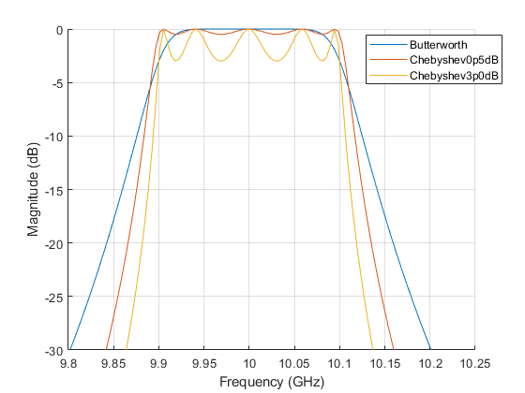

**Figure 1.** |S21| for Butterworth, .5 dB Chebyshev, and 3 dB Chebyshev filters of a 5th degree following the design conditions of the waveguide filter.

## Lumped Element to Waveguide Post

A waveguide filter utilizes distributed elements such as transmission lines and waveguide discontinuities (inductive or capacitive irises and posts) in place of the discrete inductors and capacitors used in a lumped element filter. Therefore, it is necessary to convert the lumped elements from the Chebyshev filter prototype to distributed elements. This conversion is relatively simple through the use of impedance inverters.

The conversion starts with the low pass Chebyshev prototype designed using the insertion loss method covered in [1] and shown in the appendix Figure 5. Next, because impedance inverters, or K inverters, can be used to change a shunt element into a series element, each shunt element is converted to a series inductance. At this point the K value of the impedance inverter can be chosen such that the input impedance looking towards the source or the load from the replaced component is the same. Using the impedance inverters the actual value of the series inductance is arbitrary, as the required value of the inductance can be absorbed into the K value of the inverters, this is called normalization of the element values [2]. Following normalization, the low pass filter is converted to a band pass filter using filter transformations. The K values of the inverters are determined from the absorbed filter element values and the reactance slope parameters [2]. At this point the filter is still based on discrete components, to convert to distributed components each impedance inverter is implemented using the equivalent circuit shown in the appendix Figure 5. The equivalent circuit shows a shunt inductance centered along a length of transmission line. The length of the transmission line was estimated using the design equations in [1], using the center frequency of 10 GHz, and the waveguide impedance at the center frequency. The shunt inductance is implemented using an inductive post whose value was estimated from the results of [3]. Lastly, the series resonators were replaced with half wavelength transmission lines. The half wavelength transmission lines were chosen, because at the resonant frequency a series resonator has an input impedance of zero. Therefore, if a load were attached to a series resonator and the input impedance were measured at the resonant frequency you would simply see the load impedance, which is the behavior of a half wavelength transmission line. The waveguide filter was then modeled in CST discussed next.

## Waveguide Model

The waveguide filter was modeled in CST and simulated using the initial parameter estimates previously discussed. As expected, the initial results, shown in Figure 2, reveal that significant optimization is necessary to reach the design specifications. During the optimization process the parameterized CST model was slowly, manually adjusted to improve the filter performance, while allowing for the filter to be manufactured (i.e. brass rods available in the post sizes simulated, spacing changes on the order of the milling machine tolerance). The final results after optimization are shown in Figure 2, where it is seen that the filter performance is much improved and nearly meets the design criteria set by the ideal filter model. The optimized parameter values are shown in Table 1 and were used to manufacture the filter.

**Table 1.** Optimized Parameter Values

| Parameter | Value (mm) | Parameter | Value (mm) |
| --- | --- | --- | --- |
| l3 | 23.162 | d3 | 6 |
| l2 | 22.835 | d2 | 5.5 |
| l1 | 20.353 | d1 | 2.5 |

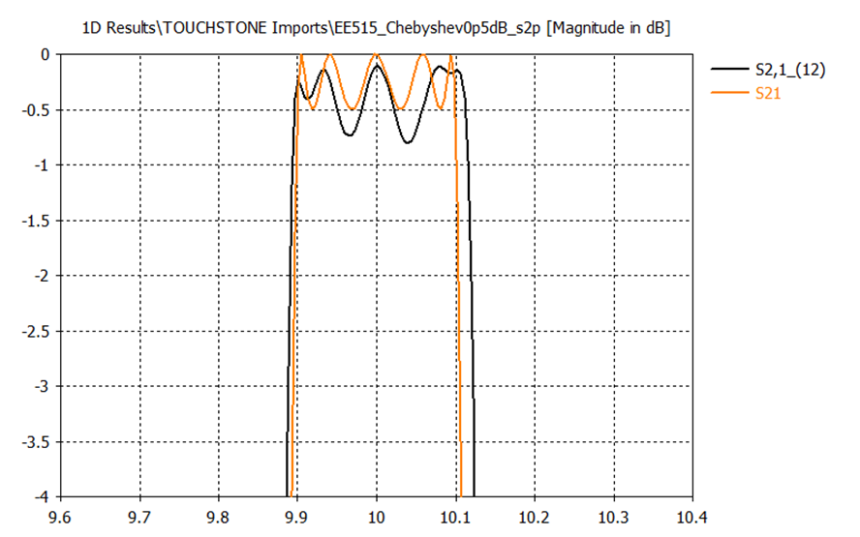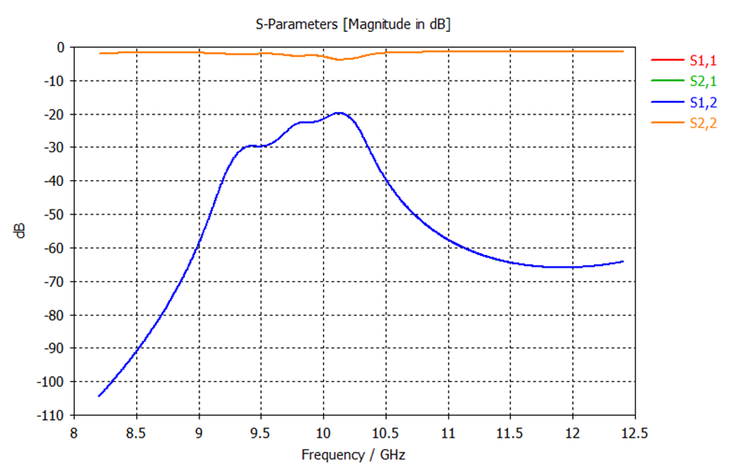

**Figure 2.** (left)|S21| for the optimized waveguide filter (black) and the ideal 0.5 dB Chebyshev filter (orange). (right) initial filter response with non-optimized parameter values.

## Manufacturing

Manufacturing of the waveguide began with stripping of enamel paint to allow access to the bare metal of the waveguide. The waveguide was then placed on a vertical knee mill with a reference plane defined on the mill. Holes were then drilled at the proper diameter and location within the mills tolerances. This resulted in the final locations being: $L_{1}=2.1560 in,$ $L_{2}=1.3550in,$ $L_{3}=0.4560 in$. Posts were manufactured from brass being purchased from McMaster Carr at the proper dimensions or turned down on a lathe. The posts were then placed in the holes with a tight mechanical fit and soldered to the waveguide with a high temperature propane source due to the waveguide’s high heat capacity and thermal conductivity. Finally, a protective coating of enamel paint was applied.

## Waveguide Filter Performance

The waveguide filter’s performance was recorded from 8.2 GHz to 12.4 GHz using a VNA and exported in the form of an S2P Touchstone file. This file was then used to simulate the filter in MATLAB, where it could be easily compared to the ideal filter that was previously generated (Figures 3 and 4).

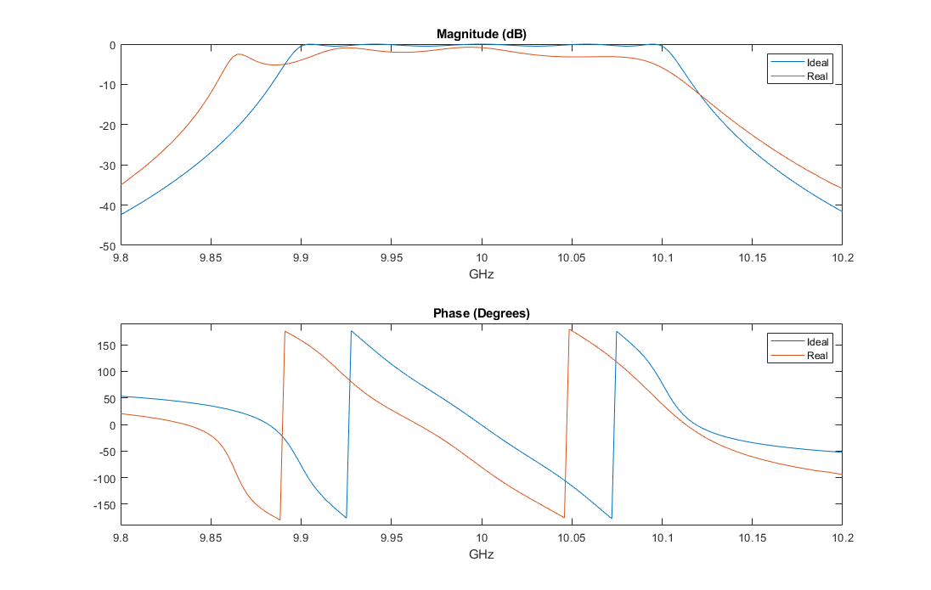

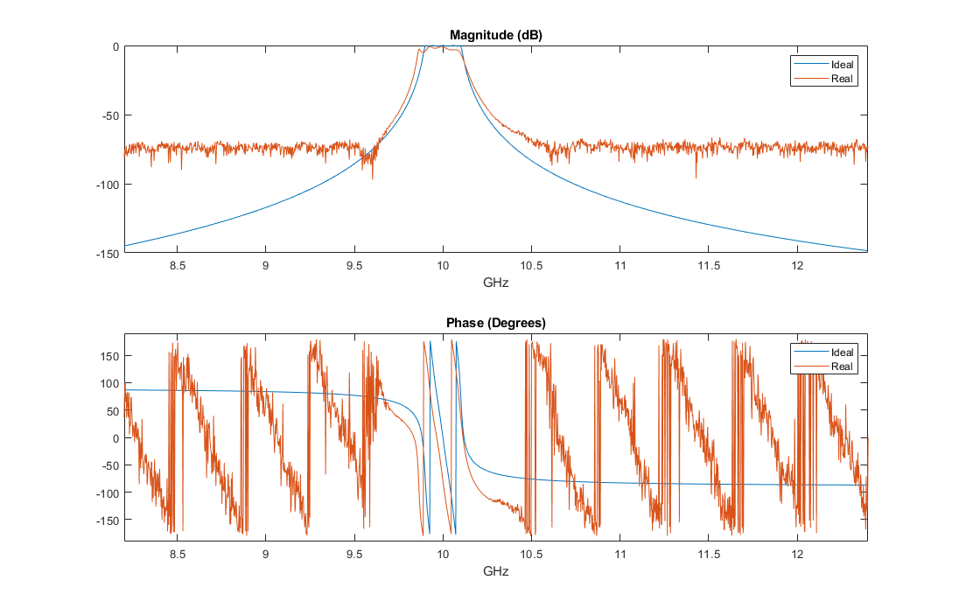

**Figure 3.** S21 for the constructed waveguide filter (orange) and the ideal 0.5 dB Chebyshev filter (blue) from 8.2 to 12.4 GHz (left) and 9.8 to 10.2 GHz (right).

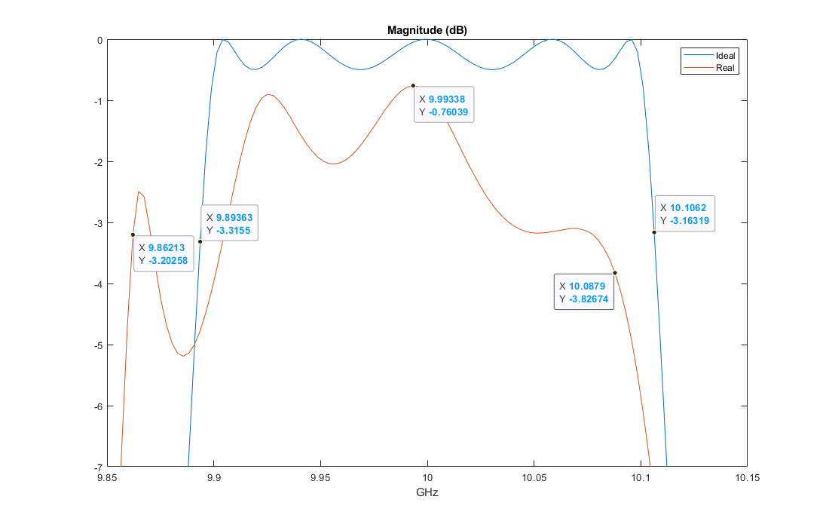

**Figure 4. |**S21| for the constructed waveguide filter (orange) and the ideal 0.5 dB Chebyshev filter (blue) from 9.85 to 10.15 GHz

## Analysis

Based on the data obtained from MATLAB, it can be seen that the waveguide filter’s frequency response in both magnitude and phase is shifted down in frequency compared to the ideal filter, causing noticeable distortion. The center frequency of the waveguide filter is very close to the target of 10 GHz at a value of 9.9934 GHz. The waveguide filter also has an attenuation of at least 0.76 dB in the passband and a 15 MHz larger bandwidth compared to the ideal filter. The shift in the frequency response, and resulting distortion, is likely due to small cumulative errors in post sizing and placement in the waveguide.

## Conclusion

In summary, a waveguide bandpass filter with a center frequency of 10 GHz and 200 MHz bandwidth was designed, built, and tested. Using analytical tools, the initial filter parameters were estimated and used as a starting point for simulation. The filter was simulated in CST for final optimization and fabricated for physical testing. Using a VNA, the frequency response of the filter was measured. The measurement results showed that the filter had a center frequency very close to 10 GHz, a bandwidth of 225 MHz, and a shift in frequency response compared to an ideal filter likely due to small cumulative errors during construction.

## References

[1]D. POZAR, *MICROWAVE ENGINEERING*, 4th ed. [S.l.]: JOHN WILEY & SONS, 2021.

[2]R. Cameron, C. Kudsia and R. Mansour, *Microwave filters for communication systems*, 2nd ed. John Wiley & Sons, Ind., 2018.

[3]Y. Leviatan, P. Li, A. Adams and J. Perini, "Single-Post Inductive Obstacle in Rectangular Waveguide", *IEEE Transactions on Microwave Theory and Techniques*, vol. 31, no. 10, pp. 806-812, 1983. Available: 10.1109/tmtt.1983.1131610.

Appendix

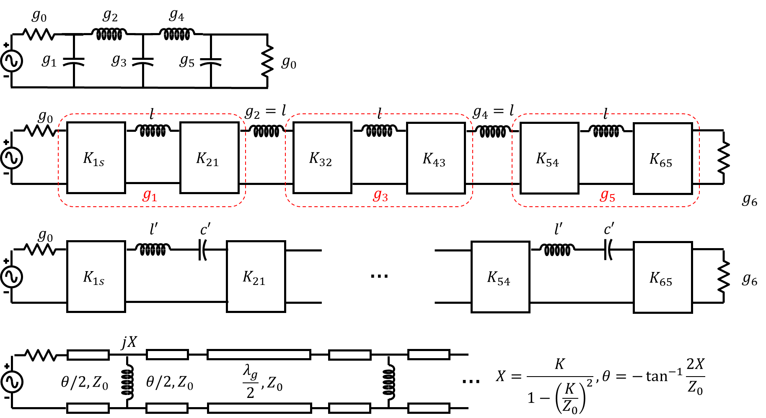

**Figure 5.** Conversion process from discrete lumped element low pass prototype to waveguide filter using impedance inverters and half wavelength series resonators.